

American International University-Bangladesh (AIUB)  
Department of Computer Science  
Faculty of Science &Technology (FST)  
Summer 21 22

Section: B  
Software Quality Assurance and Testing

Dekho: Online Streaming Platform

A Report submitted

By

| SN | Student Name | Student ID |
| --- | --- | --- |
| 1 | Sk. Sakib Islam | 18-37593-1 |
| 2 | Minhazul Hakim | 18-39155-3 |
| 3 | Refat, Mahfujar Rahman | 19-40903-2 |
| 4 | Showvik Salman Dhrubo | 19-39801-1 |

Under the supervision of

ABHIJIT BHOWMIK

Associate Professor and Special Assistant [OSA]

Department of Computer Science

Faculty of Science & Technology

American International University-Bangladesh

Software Test Plan

for

Dheko: Online Streaming Platform

Version 1.0 approved

Prepared by

Showvik Salman Dhrubo

Minhazul Hakim

Refat, Mahfujar Rahman

Sk. Sakib Islam

18.08.22

**Checked By Industry Personnel**

Name:

Designation:

Company:

Sign:

Date:

Table of Contents

Revision History 3

1. TEST PLAN IDENTIFIER: RS-MTP01.3 3

2. REFERENCES 3

3. INTRODUCTION 3

Background to the Problem 3

Solution to the Problem 4

4. REQUEIREMNT SPECIFICATION 4

4.1 System Features 4

4.2 System Quality Attributes 4

4.3 System Interface 5

4.4 Project Requirements 5

5. FEATURES NOT TO BE TESTED 5

6. TESTING APPROACH 5

6.1 Testing Levels 5

6.2 Test Tools 6

6.3 Meetings 6

7. TEST CASES/TEST ITEMS 6

8. ITEM PASS/FAIL CRITERIA 7

9. TEST DELIVERABLES 7

10. STAFFING AND TRAINING NEEDS 8

11. RESPONSIBILITIES 8

12. TESTING SCHEDULE 8

13. PLANNING RISKS AND CONTINGENCIES 9

14. APROVALS 9

# Revision History

| Revision | Date | Updated by | Update Comments |
| --- | --- | --- | --- |
| 0.1 | 2022.08.15 | Showvik Salman Dhrubo | First Draft |
| 0.2 | 2022.08.16 | Minhazul Hakim | Second Draft |
| 0.3 | 2022.08.16 | Minhazul Hakim | Third Draft |
| 0.4 | 2022.08.16 | Refat, Mahfujar Rahman | Fourth Draft |
| 0.5 | 2022.08.17 | Sk. Sakib Islam | Fifth Draft |
| 0.6 | 2022..08.17 | Refat, Mahfujar Rahman | Sixth Draft |
| 0.7 | 2022.08.18 | Showvik Salman Dhrubo | Seventh Draft |
|  |  |  |  |
|  |  |  |  |

# TEST PLAN IDENTIFIER: RS-MTP01.3

| Requirement id | Date | Requirement Description | Dependencies | originator |
| --- | --- | --- | --- | --- |
| OSLogin_1 | 16-08-2022 | Sign in for the website | Valid user | Junior Developer |
| OSRegistration_02 | 16-08-2022 | Valid user data | Check validation | Junior Developer |
| OSLogout_3 | 16-08-2022 | Remove UI from website | Log out session | Junior Developer |
| OSChangePassword_04 | 16-08-2022 | Verify user | User must be login | Junior Developer |
| OSShowPackage_05 | 16-08-2022 | Package visualization | Availability of package | Junior Developer |
| OSDeletePackage_06 | 16-08-2022 | Remove the package id | Package unique id | Junior Developer |

# REFERENCES

* SRS Documents example:<https://krazytech.com/projects/sample-software-requirements-specificationsrs-report-airline-database>
* Test Plan: <https://www.guru99.com/what-everybody-ought-to-know-about-test-planing.html>
* Test Case: <https://www.guru99.com/test-case.html>

# INTRODUCTION

## Background to the Problem

After a hectic day at the office or university or in our leisure time we always want to watch something for entertainment such as movies, series, or dramas. But we often use Torrent site which is illegal and very painful to download. There are some foreign OTT platforms out in the market but those don't have Bangladeshi content. And there are also some Bangladeshi ott platforms but those don't have a large amount of deshi content.

## Solution to the Problem

So, our goal is to make a platform where users can watch Bangladeshi content in one place without any trouble. Users can come to our system, buy subscriptions and watch their favorite movies or dramas easily. We will contact the owner of those content and make a deal that can help both the owner and the users. It is a really tough job to meet business objectives but if we once normalize this for content makers and users it will be much easier. There are some FTP Servers from different ISP but those are not accessible to everyone but our system will be accessible to everyone.

# REQUIREMENTS SPECIFICATION

## System Features

**User/Customer Features**

**1. System Registration**

Functional Requirements

2.1 The software shall allow users to sign up with a username, password, email, date of birth, and address.

2.2 The password and email must be in a valid format.

Priority Level: High  
 Precondition: user has a valid user id and password

**2. System Login**

Functional Requirements

2.1 The software shall allow users to log in with their given username and password

2.2 If the email and/or password has been inserted the wrong user must not be able to

log in.

Priority Level: High  
 Precondition: user has a valid user id and password

**3. System Logout**

Priority Level: High  
 Precondition: user must be logged in

.**4. Edit and Update profile**

Priority Level: High  
 Precondition: user must be logged in

**6. Subscribe to Package**

Priority Level: High  
 Precondition: user must be logged in

**7. Play/Stop/Next Video**

Priority Level: High  
 Precondition: user must be logged in

**8. Add Watchlist/Save to watch later**

Priority Level: Medium  
 Precondition: user must be logged in

**9. Add ratings and reviews**

Priority Level: Medium  
 Precondition: user must be logged in

**Admin Features**

**1 System Registration/Login/Logout**

Functional Requirements

2.1 The software shall allow the admin to sign up with a username, password, email, date of birth, and address.

2.2 The password and email must be in a valid format.

Priority Level: High  
 Precondition: admin has a valid user id and password

**2 CRUD Users/Customers**

Priority Level: High  
 Precondition: user must be logged in

**2.3 CRUD videos**

Priority Level: High  
 Precondition: admin must be logged in

**2.4 CRUD Packages**

Priority Level: High  
 Precondition: admin must be logged in

**2.5 CRUD Payment**

Priority Level: High  
 Precondition: admin must be logged in

**2.6 CRUD Expenses**

Priority Level: High  
 Precondition: admin must be logged in

## System Quality Attributes

**1. USABILITY:** The ease of usage can be used to measure this. The software must be simple to use. In an average of three minutes and as much as five minutes, one of our frequent users can publish about their product. Our system's functions are simple to master due to its straightforward navigation. The system is very simple to understand how to utilize for new or infrequent users.

**2. RELIABILITY AND CORRECTNESS:** Every piece of software has bugs. Our program delivers the precise outcomes users are looking for, and its accuracy is promised. Because our program has been well tested and doesn't give any false results, it is more reliable for our users to use..

**3. MODULARITY**: We must carefully create modules for every system. There are numerous components in our system, which have been merged to create a full system. Because we can quickly identify flaws in any module, our job as testers is made easier because we only need to focus on fixing that one module and don't need to consider other modules. Additionally, because our system was created in a modular way, we can also add new features to it.

**4.** **MAINTAINABILITY:** This refers to how quickly the maintenance crew can do its work. Our maintenance team's primary responsibility is to patch bugs and update or add new features. All features can be altered with a development effort of 25 hours or less by our lone maintenance programmer.

**5**. **EFFICIENCY:** The system's primary positive feature. measured in terms of the amount of time needed to finish any task that has been given to the system. The program will work well on a broad basis.

**6. TESTABILITY:** It refers to how quickly the test team can complete their assignment. Since our system was designed in modules, testers will find it simple to use and they won't need to test every module individually to find and repair errors. Testability is very module dependent.

**7. FLEXIBILITY:** The work involved in changing a program so that it works. With no more than two hours of labor, a maintenance programmer who has been supporting this product for at least eight months should be able to deliver a copy of the updated output, complete with code changes and testing.

## System Interface

**Login:**

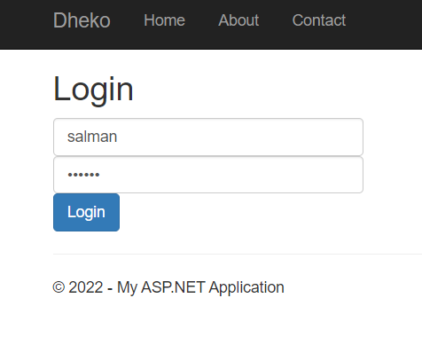

**Packages:**

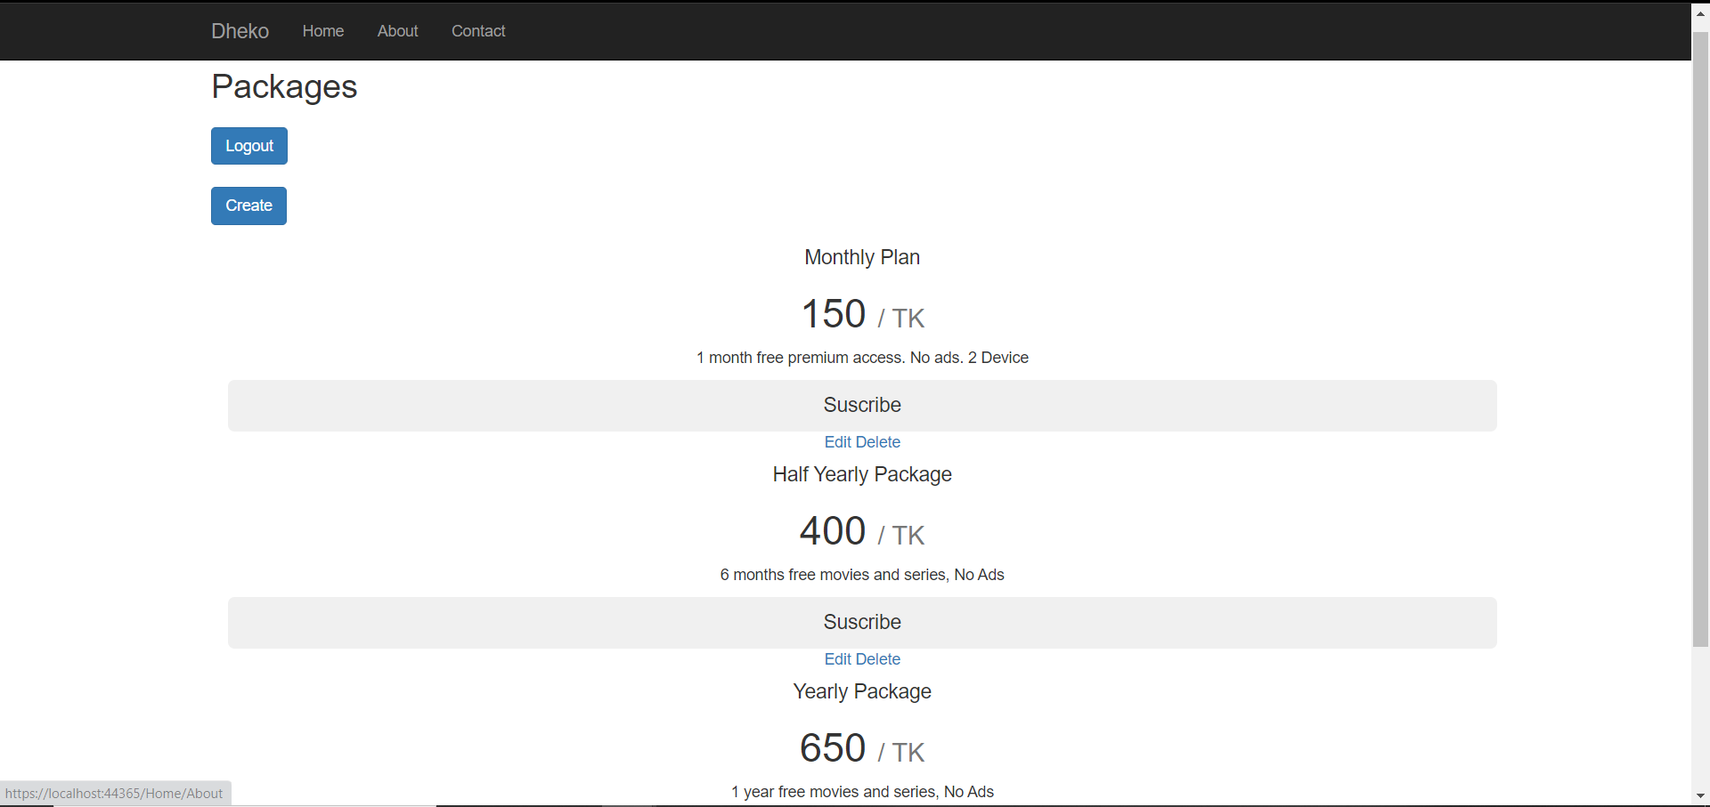

**Package Edit:**

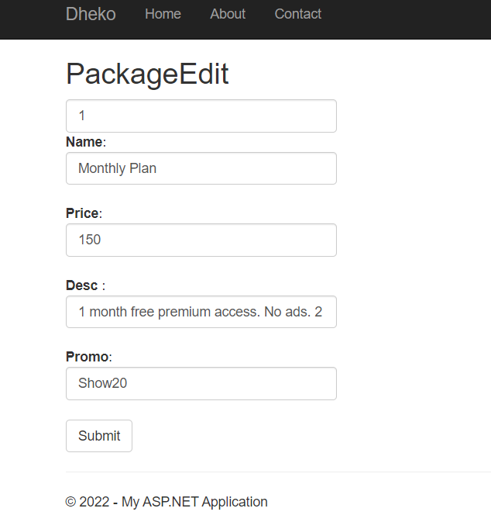

**Package Create:**

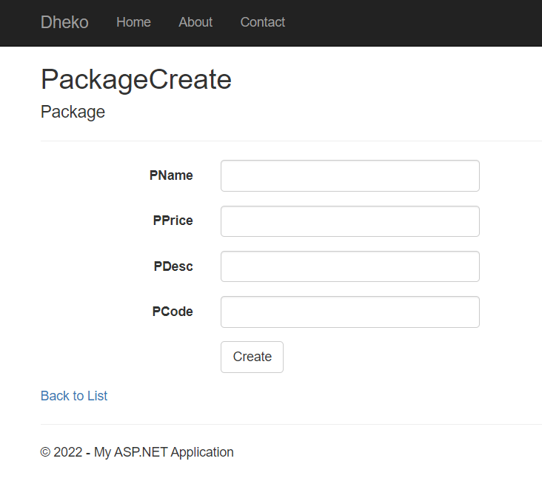

## Project Requirements

Effort Estimation:

Our project is to develop an application named “**Dekho: Online Streaming Platform**”.

Development Time = 3 Months

Required number of peoples = 4

Budget Estimation:

Duration in weeks = 3*4 = 12 weeks

Office days = 5 days

Working hours = 8 Hours

So Per week working hours is = (5*12) hours

= 60 hours

So Total Working hours is = (40*12) hours

= 480 hours.

Developer salary is = 1200 Taka

Total developers Salary = (1200*480) Taka

= 576,000 Taka

| Expanse | Amount | Total Amount |
| --- | --- | --- |
| Salary for 4 developers |  | 576000 Taka |
| 3 months office rent | 3*15000 | 45,000 Taka |
| Electricity and other costs |  | 20000 Taka |
| 1 month Maintenance  cost | 4*10*1200 | 48000 Taka |
| Travel Cost | 1*5000 | 5000 Taka |
| Total Cost |  | 694000 Taka |
| 15% of the total cost(profit) |  | 104100 Taka |
| Now the total budget is |  | 798100 Taka |

# FEATURES NOT TO BE TESTED

The following is a list of the areas that will not be tested in this release:

* There is a feature where Users can add a video to watchlists or save it to watch later that feature is not to be tested in this release of the software
* The user review and rating feature is also not to be tested due to low risk

# TESTING APPROACH

**Unit Testing:** We will perform the unit tests first. We will test distinct software units or components in this test. Every class or method, as an illustration. The aim is to guarantee that every piece of software code performs as intended. Developers carry out these tests while an application is still in the development (code) stage. We will use the "White Box Testing" method in this phase.

**Integration Testing:** The integration will then happen in the second section. We will make sure that all software modules are correctly integrated and tested collectively during this testing. The many software modules that make up our product were created by four programmers. This level of testing aims to identify flaws in how several software modules interact when combined. We'll use the "Bottom-up Integration" method in this phase.

**System Testing:** After that, we'll test the system. We will evaluate a whole, integrated system using system tests. Then, we'll see if it satisfies all the criteria. Testing with a black box falls under this category. Therefore, we will use the "Black Box Testing" method at this level.

**Acceptance Testing:** Acceptance testing is the last phase of our testing. This test is carried out to ensure that the product is acceptable. To determine whether any mistakes were made during the functional testing stage, this test is conducted. We employ a "black box testing" strategy at this level. After that, we can rerun our unit tests.

## Testing Levels

o SYSTEM/INTEGRATION Testing will be performed by the test manager and development team leader with assistance from the individual developers as required. No specific test tools are available for this project. Programs will enter into the System/Integration test after all critical defects have been corrected. A program may have up to two Major defects as long as they do not impede testing of the program (I.E. there is a workaround for the error).

o UNIT TESTING will be done by the developer, and the results will be authorized by the team lead. Before unit testing may be accepted and passed on to the test person, the programmer must submit proof of unit testing (test case list, sample output, data printouts, defect information). The test person will receive all unit test information as well.

o The customer will do ACCEPTANCE testing with the help of the test manager and development team leader. After the System/Integration test is completed, the acceptance test will run in parallel with the existing manual ZIP/FAX process for one month.

## Test Tools

**Selenium:**

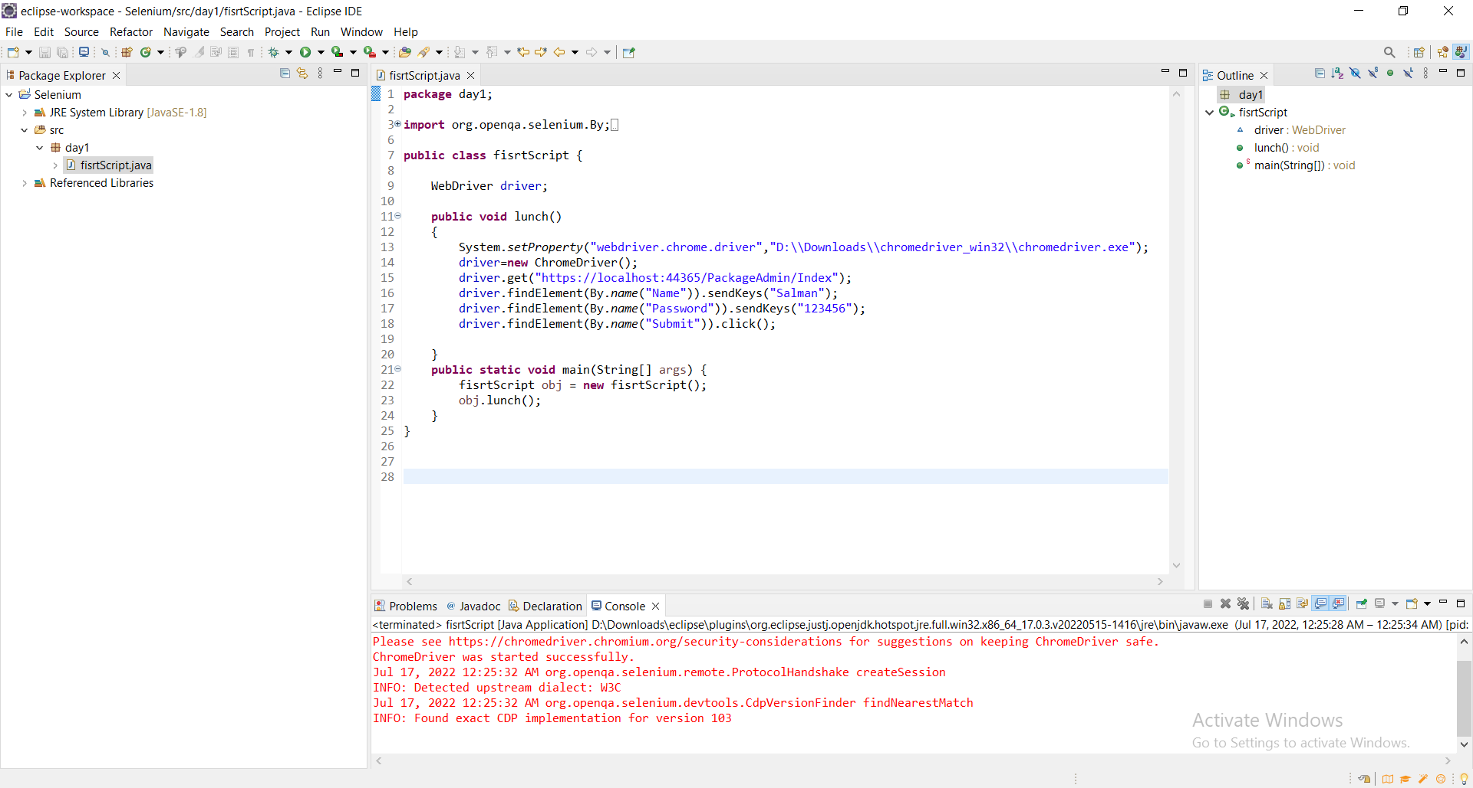

**Postman :**

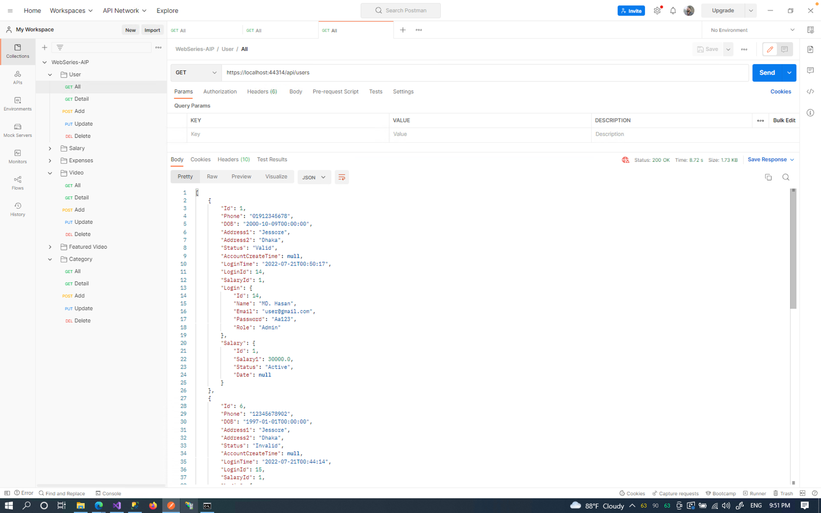

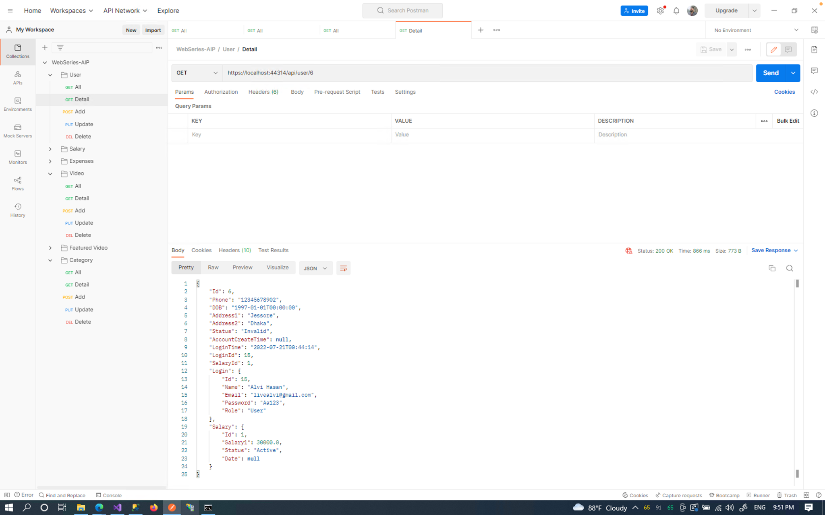

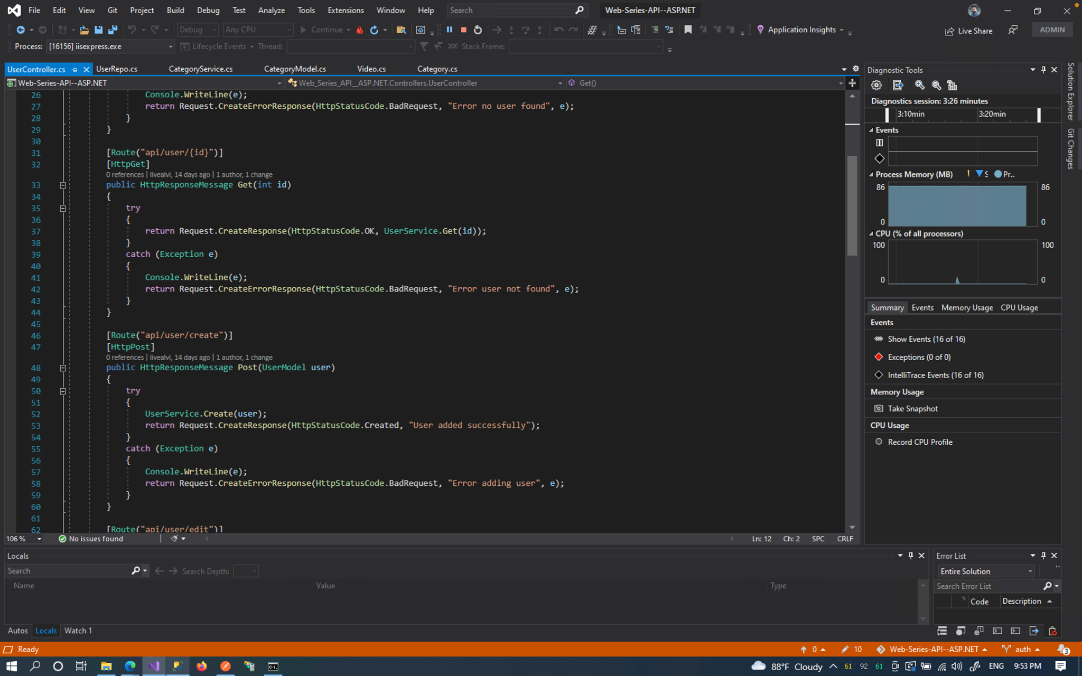

## Meetings

For a successful testing team, one of the main factors is to give the right job to the correct person. So holding regular team meetings is very important for a successful team. So the test team will meet once a week to evaluate each member's progress and determine whether or not they have completed their allocated tasks. And check if they are facing any issues. if they face any issues then other teams will support him and work to find a quick solution. The testing team leaders will meet with the project manager and development team once every two weeks. If there is any emergency there will be an extra meeting

# TEST CASES/TEST ITEMS

## 7.1 Log in

Test the website login page by verifying valid username and password

| Project Name: Dheko: Online Streaming Platform | | | Test Designed by: Refat, Mahfujar Rahman | | |
| --- | --- | --- | --- | --- | --- |
| Test Case ID: OSLogin_1 | | | Test Designed date: 16-08-2022 | | |
| Test Priority (Low, Medium, High): High | | | Test Executed by: Showvik Salman Dhrubo | | |
| Module Name: Login Session | | | Test Execution date: 17-08-2022 | | |
| Test Title: verify login with a valid username and password | | |  | | |
| Description: Test website login page | | |  | | |
| Precondition (If any): User must have valid username and password | | | | | |
| Test Steps | Test Data | Expected Results | | Actual Results | Status (Pass/Fail) |
| 1. Go to the website 2. Enter username 3. Enter password 4. Click submit | Username: Salman  Password: 321 | User should login into the application | | As expected, | Pass |
| Post Condition: User is validated with database and successfully login to account. The account session details are logged in the database. | | | | | |

**7.2 Registration**

Check the registration with a valid username, email, password, and date of birth

| Project Name: Dheko: Online Streaming Platform | | | Test Designed by: Refat, Mahfujar Rahman | | |
| --- | --- | --- | --- | --- | --- |
| Test Case ID: OSRegistration_02 | | | Test Designed date:16-08-2022 | | |
| Test Priority (Low, Medium, High): Medium | | | Test Executed by: | | |
| Module Name: Registration Session | | | Test Execution date: | | |
| Test Title: Registration with a valid username, email, and password, date of birth, address | | |  | | |
| Description: Test website registration page | | |  | | |
| Precondition (If any): User must fill up all the input field. | | | | | |
| Test Steps | Test Data | Expected Results | | Actual Results | Status (Pass/Fail) |
| 1. Go to the website 2. click the registration button 3. Enter all the valid information. 4. click “Submit” button | Username: Salman  gmail: [Salman@gmail.com](mailto:Salman@gmail.com)  Date of birth: 16-01-1999  Gender: male  password: 123  address: Dhaka | User should register to the website. | | As expected, | Pass |
| Post Condition: User is validated with database and successfully register an account. | | | | | |

**7.3 Log out**

Test logout option is working or not

| Project Name: Dheko: Online Streaming Platform | | | Test Designed by: Refat,Mahfujar Rahman | | |
| --- | --- | --- | --- | --- | --- |
| Test Case ID: OSLogout_3 | | | Test Designed date: 16-08-2022 | | |
| Test Priority (Low, Medium, High): High | | | Test Executed by:Showvik Salman Dhrubo | | |
| Module Name: Logout Session | | | Test Execution date: 17-08-2022 | | |
| Test Title: verify logout option | | |  | | |
| Description: Test website logout page | | |  | | |
| Precondition (If any): User must be login | | | | | |
| Test Steps | Test Data | Expected Results | | Actual Results | Status (Pass/Fail) |
| 1. Go to the website 2. click logout |  | User should logout into the application | | As expected, | Pass |
| Post Condition: User successfully logout to account. and go back to the home page | | | | | |

**7.4 Change Password**

Check the change password feature is working accurately or not

| Project Name: Dheko: Online Streaming Platform | | | Test Designed by: Refat,Mahfujar Rahman | | |
| --- | --- | --- | --- | --- | --- |
| Test Case ID: OSChangePassword_04 | | | Test Designed date: 16-08-2022 | | |
| Test Priority (Low, Medium, High): High | | | Test Executed by: Minhazul Hakim | | |
| Module Name: Update password | | | Test Execution date: 17-08-2022 | | |
| Test Title: Can change password | | |  | | |
| Description: Test password is update or not | | |  | | |
| Precondition (If any): User must be login | | | | | |
| Test Steps | Test Data | Expected Results | | Actual Results | Status (Pass/Fail) |
| 1. Go to the website 2. login the site 3. write new password 4. click change password button | new Password: 123 | successful update password | | As expected, | Pass |
| Post Condition: update password is stored the database | | | | | |

**7.5 Show Package**

check feature is showing or not

| Project Name: Dheko: Online Streaming Platform | | | Test Designed by: Refat,Mahfujar Rahman | | |
| --- | --- | --- | --- | --- | --- |
| Test Case ID: OSShowPackage_05 | | | Test Designed date: 16-08-2022 | | |
| Test Priority (Low, Medium, High): Medium | | | Test Executed by: Minhazul Hakim | | |
| Module Name: Show Package | | | Test Execution date: 17-08-2022 | | |
| Test Title: show all the package with their corresponding details | | |  | | |
| Description: Test all the package are visible or not | | |  | | |
| Precondition (If any): User Must have to login and go to package page | | | | | |
| Test Steps | Test Data | Expected Results | | Actual Results | Status (Pass/Fail) |
| 1. Go to the website 2. login the site 3. go package page |  | Can see all the package with details | | As expected, | Pass |
| Post Condition: | | | | | |

**7.6 Delete Package**

test case will check the test delete package option

| Project Name: Dheko: Online Streaming Platform | | | Test Designed by: Refat,Mahfujar Rahman | | |
| --- | --- | --- | --- | --- | --- |
| Test Case ID: OSDeletePackage_06 | | | Test Designed date: 16-08-2022 | | |
| Test Priority (Low, Medium, High): Medium | | | Test Executed by: Sk. Sakib Islam | | |
| Module Name: Delete package | | | Test Execution date: 17-08-2022 | | |
| Test Title: delete package with their unique id | | |  | | |
| Description: Test the delete package option | | |  | | |
| Precondition (If any): 1.User Must have to login and go to package page.  2.User must type the package id | | | | | |
| Test Steps | Test Data | Expected Results | | Actual Results | Status (Pass/Fail) |
| 1. Go to the website 2. login the site 3. go package page 4. type the package id in the input field 5. click the delete option | Package id =”p1” | Remove the package from the package page | | As expected, | Pass |
| Post Condition: the information that is stored in the database for the package will be removed. | | | | | |

# ITEM PASS/FAIL CRITERIA

We have used a total of 6 test cases in our implementation. Initially, 90% of the test cases that were applied to the system were passed successfully, while 10% of the test cases failed. Due to several database query-related problems, the test cases were failing. All test cases have been successfully completed when applied after a query-related issue has been resolved.

# TEST DELIVERABLES

* Acceptance test plan
* System/Integration test plan
* Unit test plans/turnover documentation
* Screen prototypes
* Report mock-ups
* Defect/Incident reports and summaries
* Test logs and turnover reports

# STAFFING AND TRAINING NEEDS

This section outlines the hiring process and how to train employees for test positions. For the duration of the project, staffing is fixed. It's reasonable to presume that the majority of employees will consent to participate in some testing. The following professions are acknowledged:

**Project Manager:** Responsible for maturing the Web site's full execution. This entails developing requirements, coordinating the testing process, and managing the seller relationship.

**Test manager:** Fostering the expert test strategy, assessing the test deliverable, managing test cycles, gathering measurements and updating the project manager on progress, and advising when testing should be finished are all under their purview.

**Test Engineer:** This position's duties include organizing tests, developing test methods, developing test information, conducting tests, writing mechanized test strategies, making occurrence reports, reviewing episodes, and providing measures to the test administrator.

The website development life cycle should be known to the test manager and test professionals. This is only one example of the staffing and training needs because this project is being developed traditionally. The names of the conscious contributors to each initiative are so withheld.

# RESPONSIBILITIES

| Name | Role | Responsibilities |
| --- | --- | --- |
| Hakim, Minhazul | Project Manager | 1. Completion of the Project.  2. Execute all the test cases and report defects.  3. Control whole project. |
| Refat, Mahfujar Rahman | Quality Analyst | 1. Creation of test plans, test forms, test cases and test information.  2. Carry out testing as per the characterized methods. 3.Prepare all reports related to program testing carried out. |
| Showvik Salman Dhrubo | Programmer | 1. Researching, designing, implementing, and managing software programs.  2. Writing and implementing efficient code.  3. Deploying software tools, processes, and metrics. |
| Sk. Sakib Islam | Test Engineer | 1. Characterizing the testing activities All obligations of test planning  2. To check in the event that the group has all the fundamental assets to execute the testing exercises.  3. Prepare the report of testing activities.  4. Overhauling extend directors frequently around the advance of testing exercises.  5. Develop test cases and prioritize testing activities.  6. Execute all the test cases and report defects.  7. make documentation |

# TESTING SCHEDULE

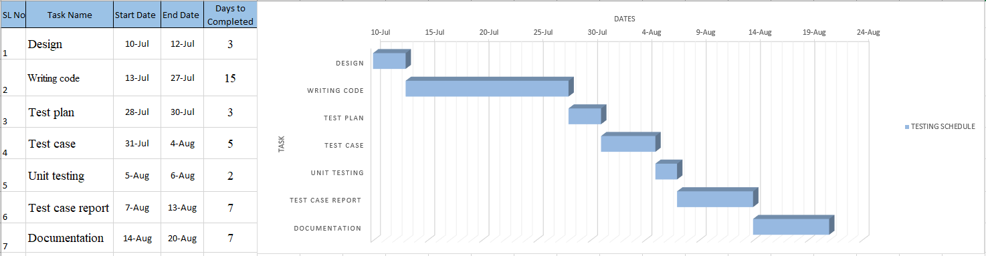

# PLANNING RISKS AND CONTINGENCIES

| Risk | Probability | Impact | Mitigation |
| --- | --- | --- | --- |
| Error in function | Medium | Medium | Regularly test the web application, and save a regular backup. |
| Give invalid input | High | High | Remind the user to enter the proper data type in each input area. |
| Loss of encrypted data(password) | Medium | High | Maintain security and backup |

# APROVALS

| Project Sponsor | Showvik Salman Dhrubo |
| --- | --- |
| Development Management | Refat, Mahfujar Rahman |
| EDI Project Manager | Minhazul Hakim |
| RS Test Manager | Sk. Sakib Islam |
| RS Development Team Manager | Showvik Salman Dhrubo |
| Reassigned Sales | Refat, Mahfujar Rahman |
| Order Entry EDI Team Manager | Minhazul Hakim |